Assignment No | 2
Title | Analytical Queries
Objective | Roll_Up, CUBE , First, Last, Lead, Lag, Row_number ,Rank and Dense Rank
Roll No | MCA2649

Source Code:-
CREATE TABLE Employee (
empNo NUMBER(6),
Name VARCHAR2(10),
Position VARCHAR2(6),
manager NUMBER(6),
JoinDate DATE,
Salary NUMBER(7),
DeptNo NUMBER(3)
);

Output:

Creating a Table: Employee Table and Inserting Values in the Table

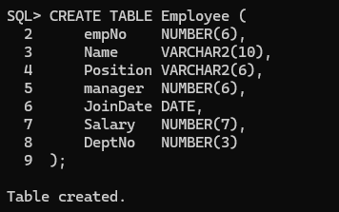

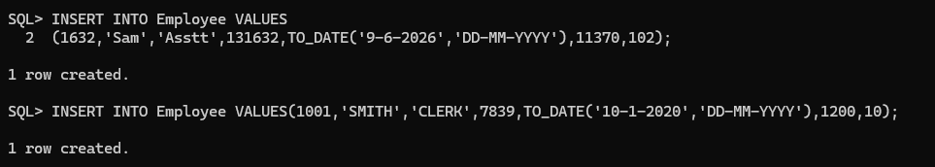

- ROLLUP:-
- One Column Without ROLLUP: Displays the total salary of employees for each department without showing subtotals or a grand total.
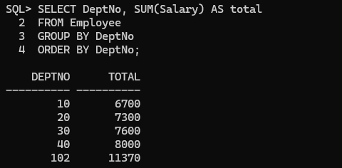
- One Column With ROLLUP: Displays the total salary of employees for each department along with the grand total.
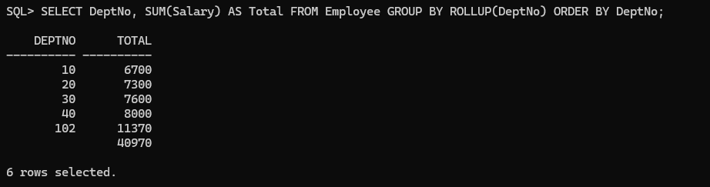
Difference: GROUP BY DeptNo shows the total salary for each department, while GROUP BY ROLLUP(DeptNo) shows the department-wise totals plus the grand total.

- Multiple Columns Without ROLLUP: Displays the total salary for each combination of Department and Position without showing subtotals or a grand total.
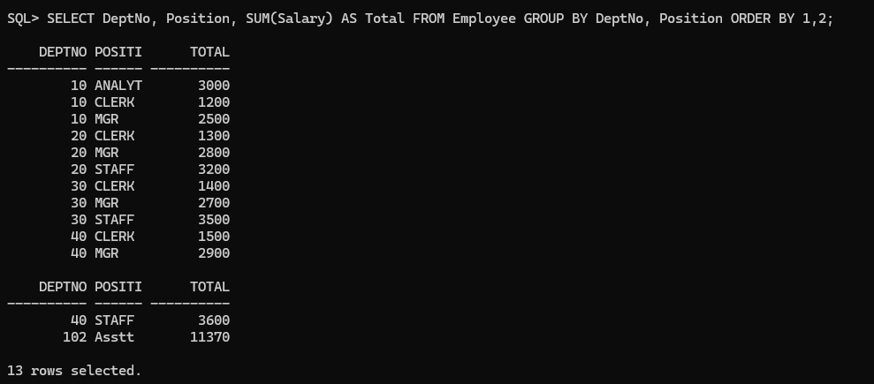

- Multiple Columns With ROLLUP: Displays the total salary for each Department and Position combination, along with department-wise subtotals and a grand total.
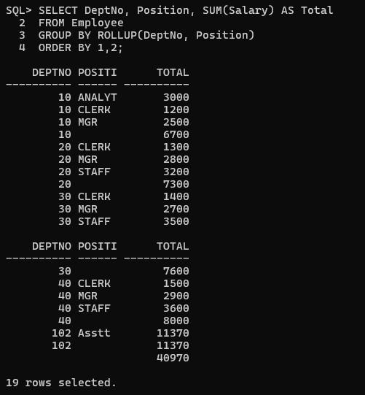

Difference: GROUP BY DeptNo, Position gives only combination-wise totals, while ROLLUP(DeptNo, Position) gives combination-wise totals plus department subtotals and a grand total.

2)CUBE:-
- One Column With CUBE: Displays the total salary of employees for each department along with the grand total.

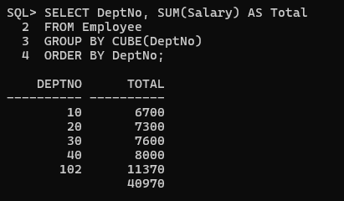

- Multiple Columns With CUBE: Displays the total salary for each Department and Position combination, along with department-wise subtotals, position-wise subtotals, and the grand total.

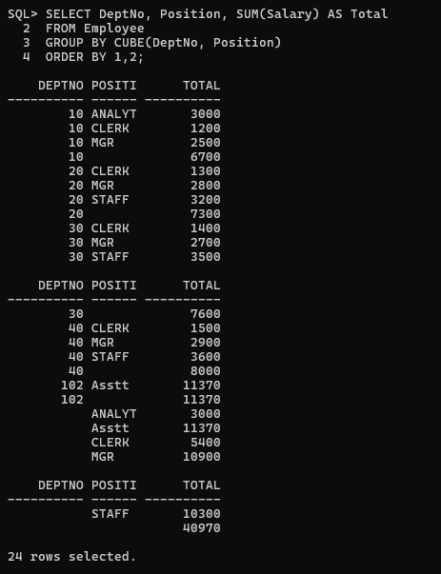

Difference: Multiple Columns With CUBE displays Department–Position totals, department-wise subtotals, position-wise subtotals, and the grand total, whereas Multiple Columns Without CUBE displays only Department–Position totals.

